James Stallkamp
CS 478
Identify the Traffic
Contents
Executive Summary 1
Technical Summary 1
File 1 1
File 2 2
File 3 2
File 4 2

Executive Summary
In this exercise I inspected packets for VPN activity. Being able to identify traffic activities is crucial for network security engineers to identify suspicious behavior that might indicate attacks. In these examples I was looking for evidence of VPN traffic by identifying specific network protocols that were used along with some other attributes. For most known VPN protocols there are ports associated with that kind of traffic, the combination of a known VPN protocol with its known port is highly indicative of VPN traffic. Other things that I looked for were evidence of high traffic volumes between two specific addresses, indicating tunneling, also that the traffic itself was encrypted further indicating VPN traffic. For file 1 this was very straightforward because there was an obvious VPN protocol that was used with a known port repeatedly, which matches nearly all the criteria. Unfortunately I did not have to time to properly finish the rest of the files and will only be submitting the first file.

Technical Summary

File 1
For file 1 I see three clear periods of VPN like traffic. Packets 1 through 12, 21 and 22, and 27 and 28. All the packets mentioned are using the protocol 2TPv3 L2TP which typically works with UDP port 1701, which is visible in the packet details pane. The packets in the capture show L2TP control messages, which indicate a VPN session setup and management. Additionally, the traffic is consistently between two addresses suggesting that tunneling is going on, another sign of VPN traffic. Finally, there are no visible application-layer protocols like HTTP, DNS, or SMTP suggesting encrypted tunneling. This combination of characteristics highly suggests that the packets identified are using a VPN.
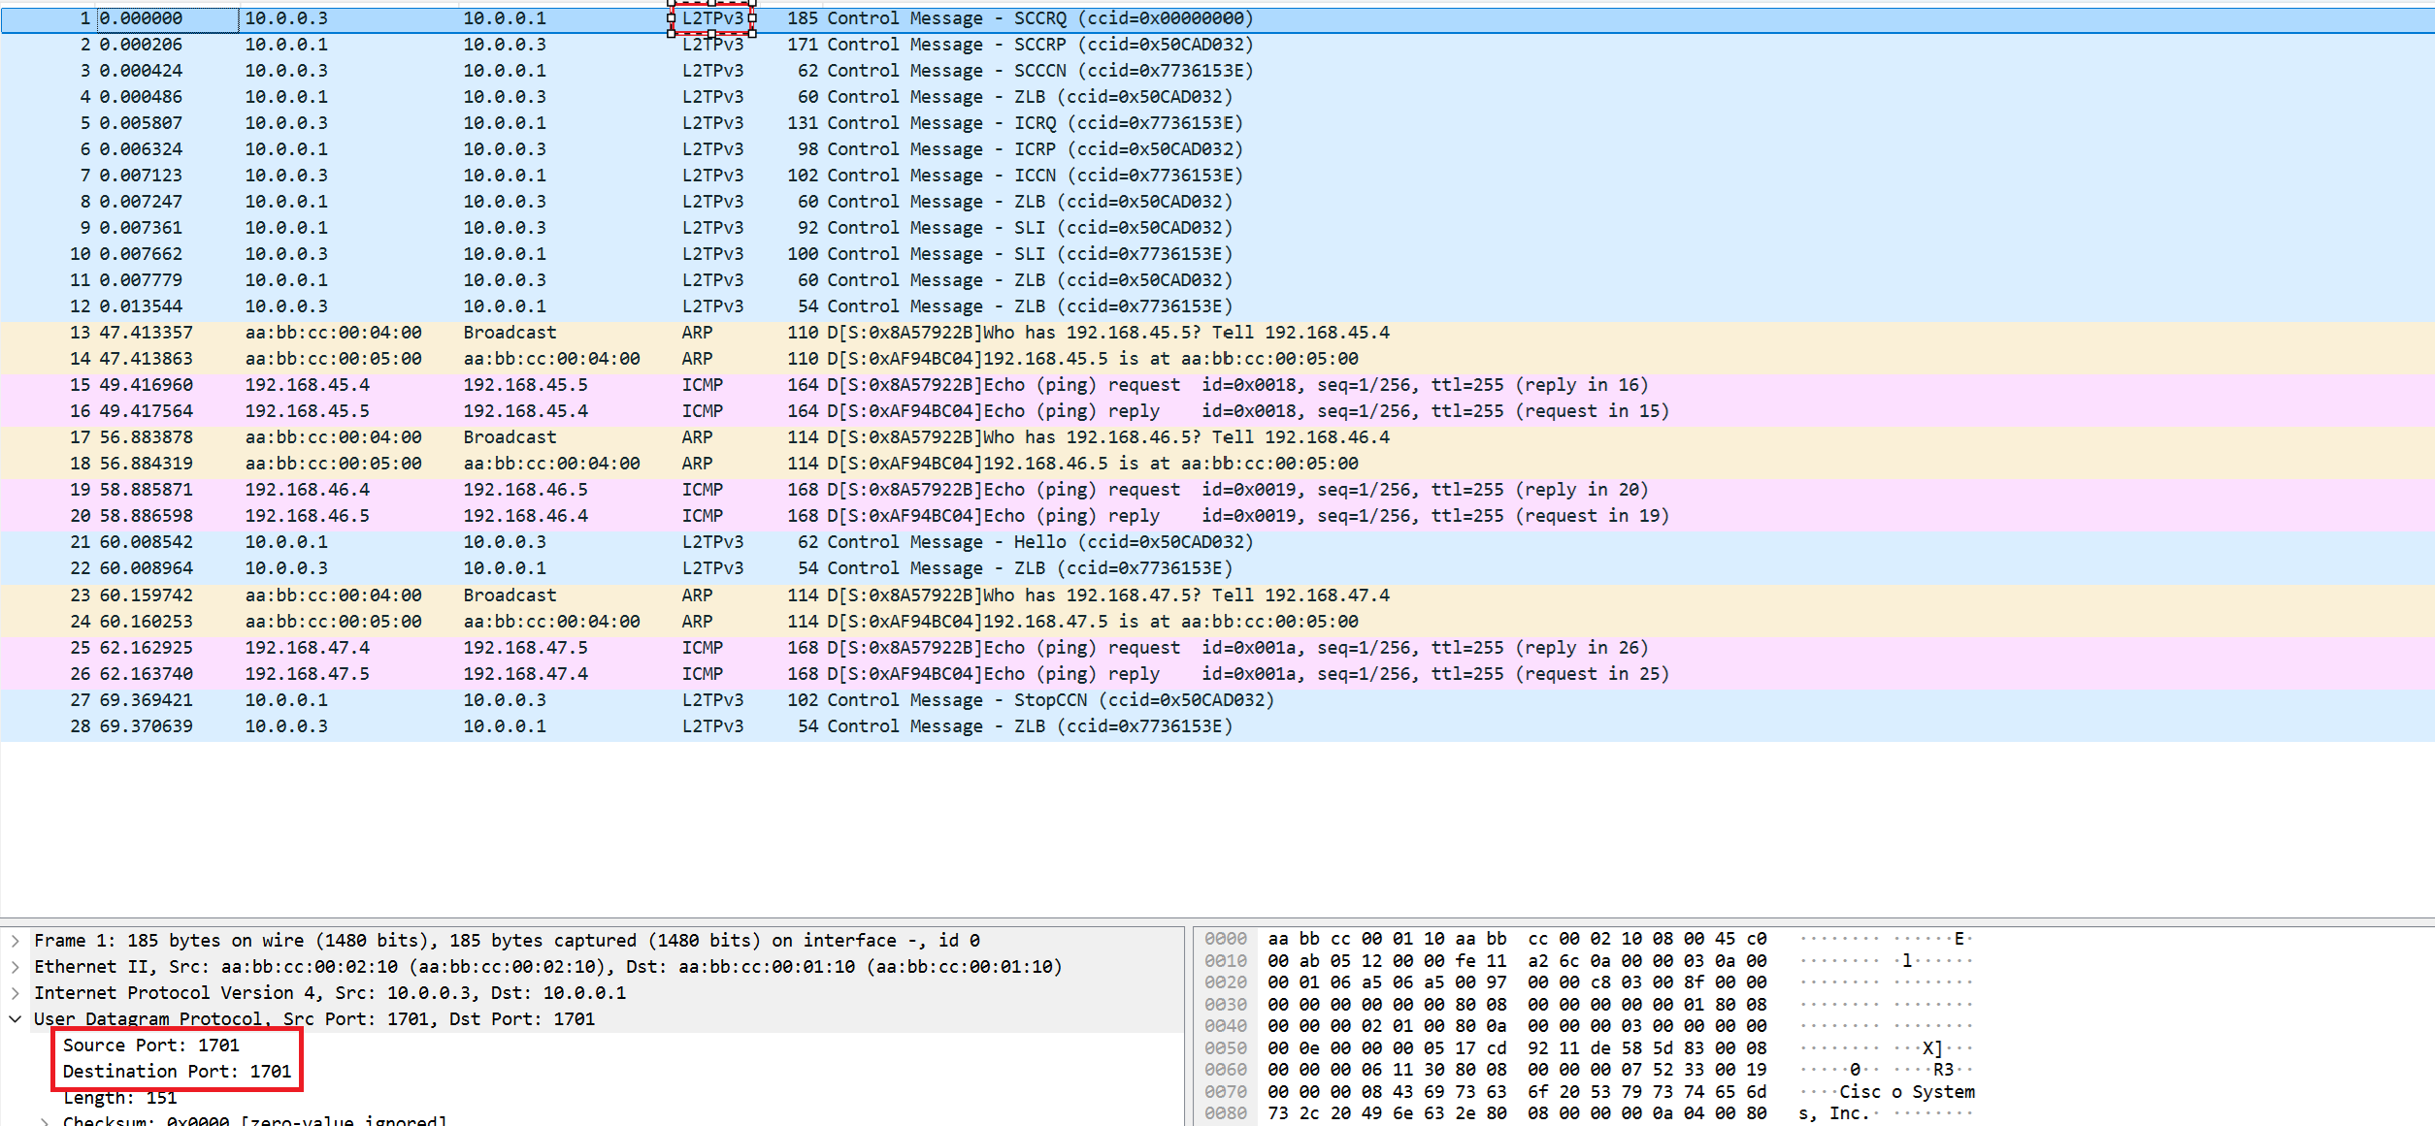

File 2
Did not complete.

File 3
Did not complete.

File 4
Did not complete.

